DATE: 6,9,2024

NAME:UGIRIWABO Drocelle

CLASS:C

ASSIGNMENT OF ALGORITHM AND STRUCTURE

Q1.tools used to run the c program

1.dev++

2.atom

3.cllion

4.embarcadoro c++

This picture it shows step by step of running c program

Step1:download of dev C++

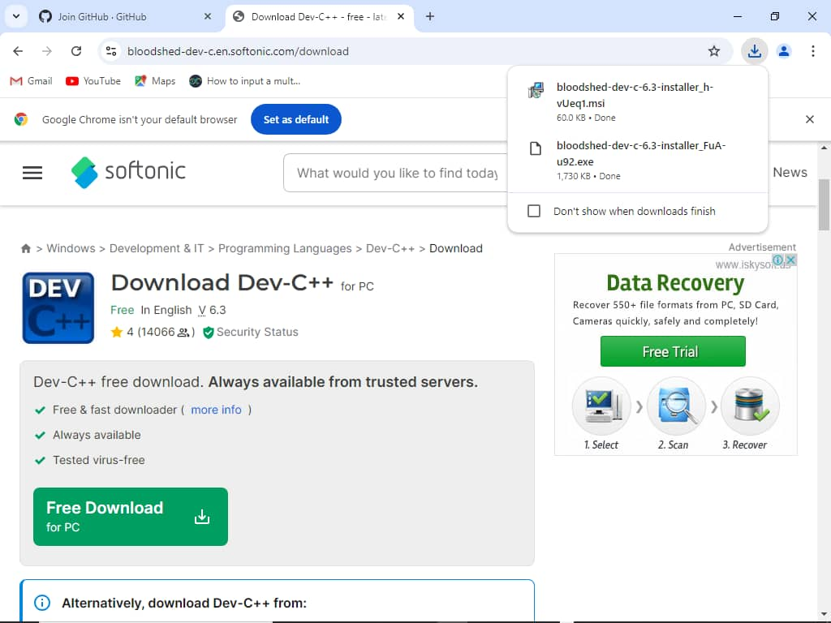

Step2:installation of dev C++

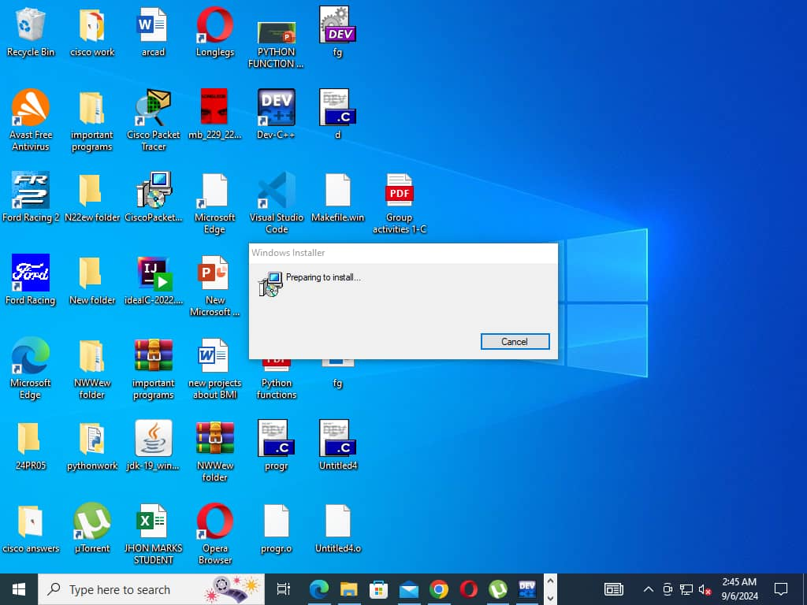

Step3:is to open dev C++

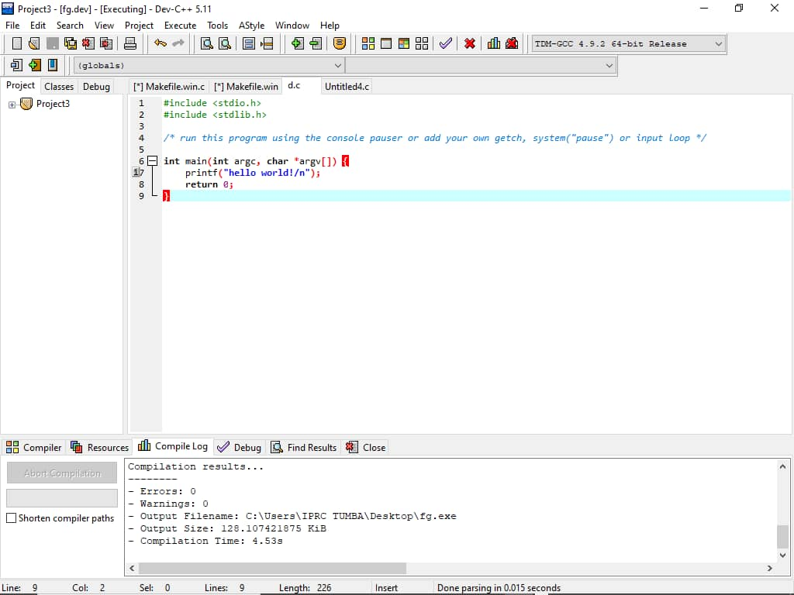

Step4:This picture shows executable of sourcecode

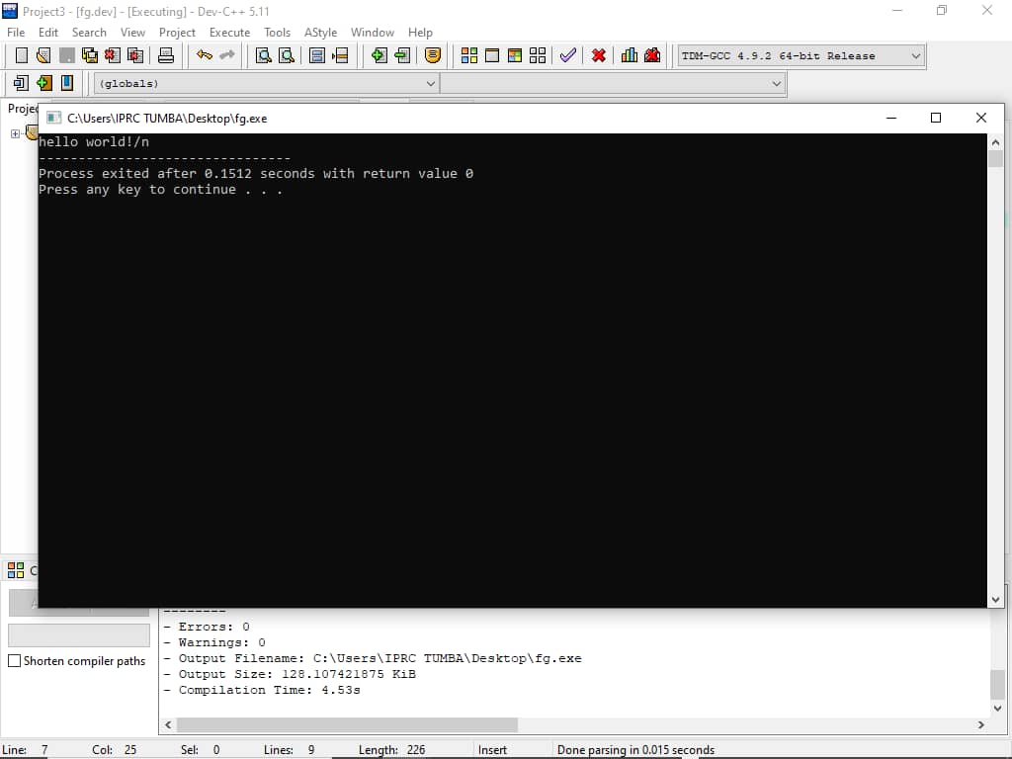

After using c programming I use ghitub and git inorder to invite corabullation.

Conclusion:using ghitub is good when you want ta do corabullation